 | 12 ATAR Physics  EM Test 2016
  Student name:

1. The following diagram represents a generator with a coil of 35 loops, 15.0cm wide by 28.0cm long. The field strength between the poles is 0.0125 T and the coil is spinning clockwise at a rate of 1380 cycles per minute. The arrows show the direction of induced current in the circuit.  (a) Label the poles of the magnet shown in the diagram. (1 mark)  (b) Calculate the maximum flux passing through the coil as it spins (3 marks) | 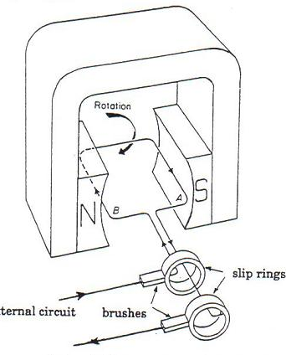

(c) This type of generator is also known as an alternator. Explain why is it called an alternator. (1 mark)

(d) Calculate the peak (maximum) EMF generated. (4 marks)

(e) Calculate the effective (root mean square) voltage produced by the generator. V_{RMS} = V_{PEAK} ÷ √2. (2 marks)

(f) What is the value of the EMF when the coil is perpendicular to the magnetic field (B). Use your knowledge of EM theory to explain why the value of the EMF is zero in this situation. (4 marks)

2. A magnet is moved towards a coil of diameter 7.60cm and consisting of six loops. The resistance of the coil wire is 0.222 Ohms. During this time the magnetic field strength passing through the coil increases from 2.00x10⁻³ T to 9.00x10⁻³ T generating an induced current 0.0345 Amps.

N
S
N
S
X Y

(a) Draw an arrow on the wire XY to show the direction of the induced current as the magnet is moved towards the coil. (1 mark)

(b) For long was the magnet moving toward the coil? (4 marks)

3. A steel rod of length 2.00 metres and diameter 15.0cm falls vertically from the top of a roof. Half way down it is travelling at 5.00ms⁻¹. The horizontal (S → N) component of the earth’s magnetic field at this location is 2.88x10⁻⁵ T.

(a) How should the rod be oriented for a maximum EMF to be induced in it as it falls from the roof? Use a diagram to help explain your answer. (2 marks)

N  E  W  S | Diagram

(b) Which end of the rod will be positively charged? Use a diagram to help show your answer. (1 mark)

Diagram

(c) Calculate the maximum EMF that would be induced in the steel rod as it falls with a speed of 5.00 ms⁻¹. (3 marks)

4. Energy consumption in our homes is measured in kilowatt-hours (kWh). Show that one kilowatt-hour is equal to 3.6 x 10⁶ Joules. (3 marks)

5. One bar magnet (X) is dropped through an aluminium cylinder. An identical magnet (Y) is dropped through a plastic cylinder.  Which magnet will fall through its  cylinder first (X, or Y)? ______  Using your knowledge of EM theory, explain your answer. (3 marks) | Aluminium cylinder  Plastic cylinder  X  Y

6. The maximum power through the primary coil of a 100% efficient transformer is 1200 W at a voltage of 240 V. The primary coil has 800 turns. The secondary current produced is 50.0 A and is used to operate an electric motor.

(a) What voltage is produced in the secondary coil? Draw a diagram to help explain your answer. (4 marks)

(b) How many turns does the secondary coil contain? (2 marks)

(c) Most transformers are not 100% efficient.

(i) Identify one source of power loss in the transformer core. (1 mark)

(ii) Using your knowledge of EM theory, explain why the answer you gave for (c)(i), causes a reduction of efficiency. (3 marks)

(iii) Identify one way that transformer core power loss cam be reduced.
(1 mark)

7. A power station produces 300 MW of electric power for a distant city. Just outside the power station a 100% efficient transformer boosts the voltage to 500 kV. The power loss (and therefore also the voltage loss) occurring along the transmission wires is 5.50%. | 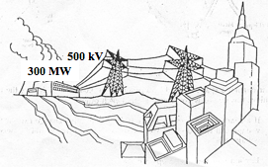

(a) Calculate the power lost along the transmission wires. (2 marks)

(b) Calculate the current flowing in the transmission wires. (2 marks)

(c) Calculate the resistance of the transmission cables. (2 marks)

(d) Calculate the voltage available at the city. (2 marks)

